MIKRON HPM450U v1 is composed by the following components:

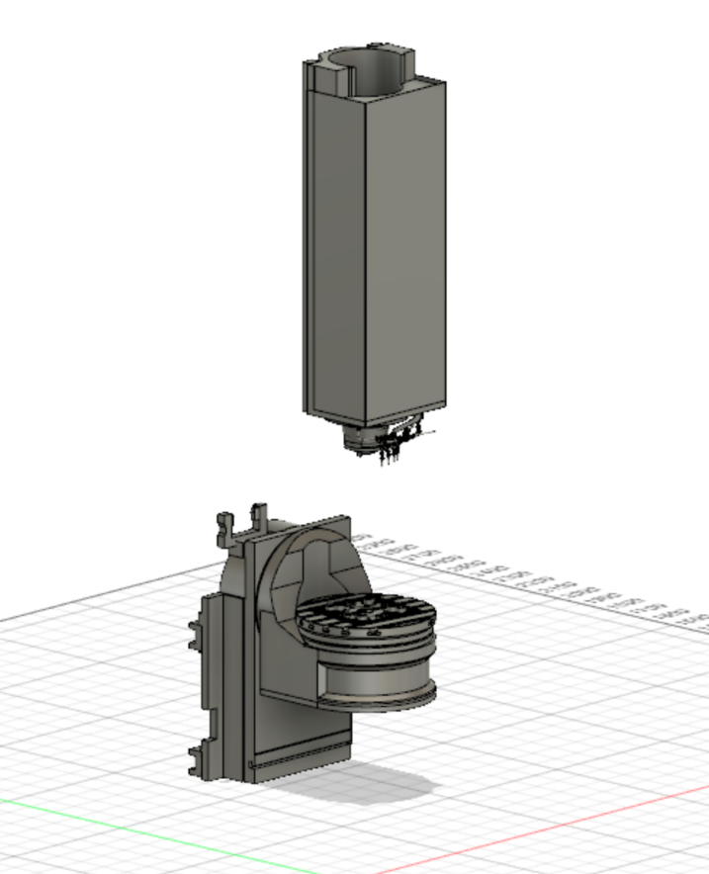

Dynamic   
parts

The blocks are used to identify the dynamic parts that the machine is composed of.